Extract, Transform, Load and generate report using Banking dataset

STEP 1

EXTRACTING DATING AS A EXCEL FILE

TRANSFERRING THE DATA FROM SOURCE TO DESTINATION i.e FROM EXCEL TO DATABSE

GROUPING OPERATIONS

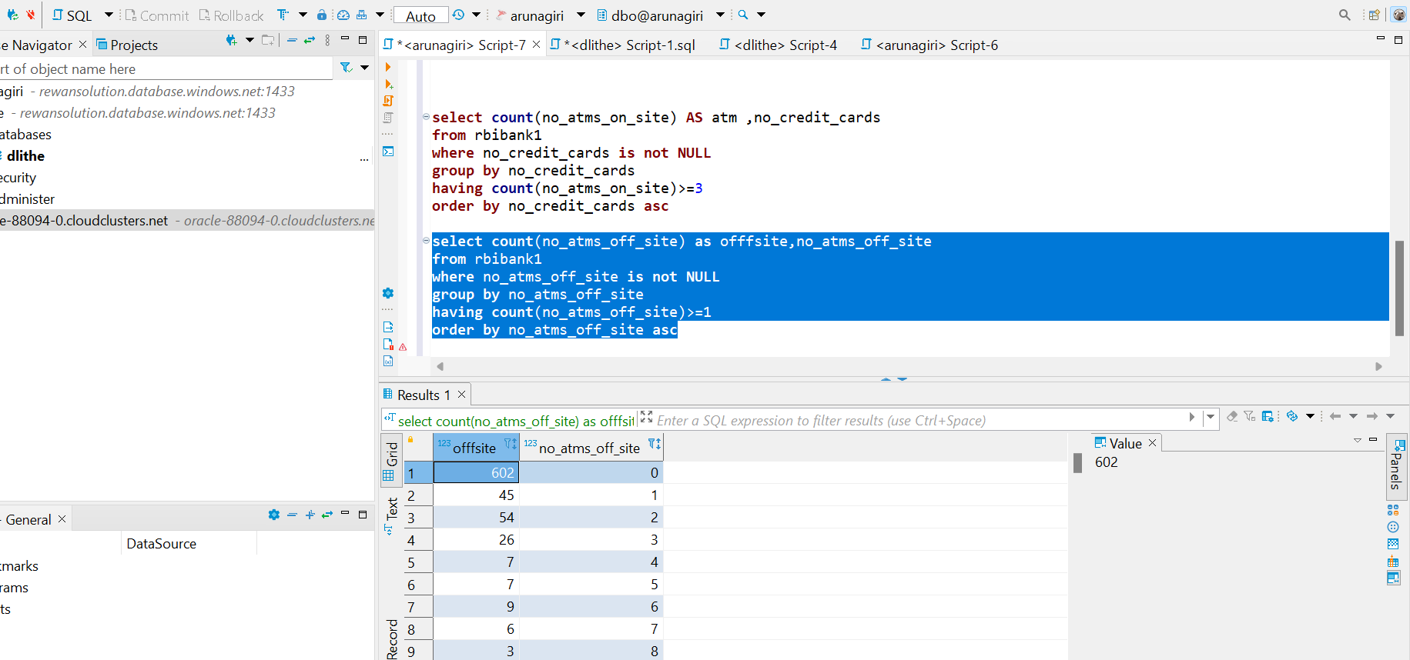

SSRS OPERATION

CHARTS

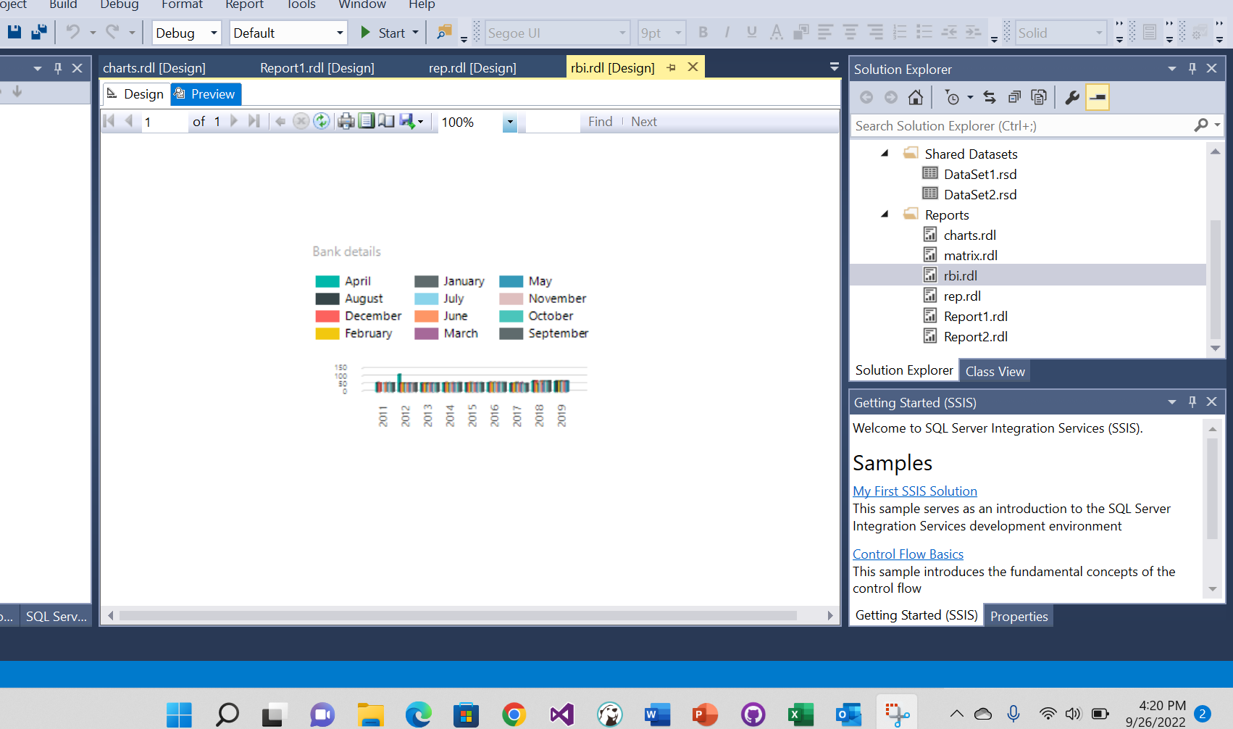

MATRIX TABLE

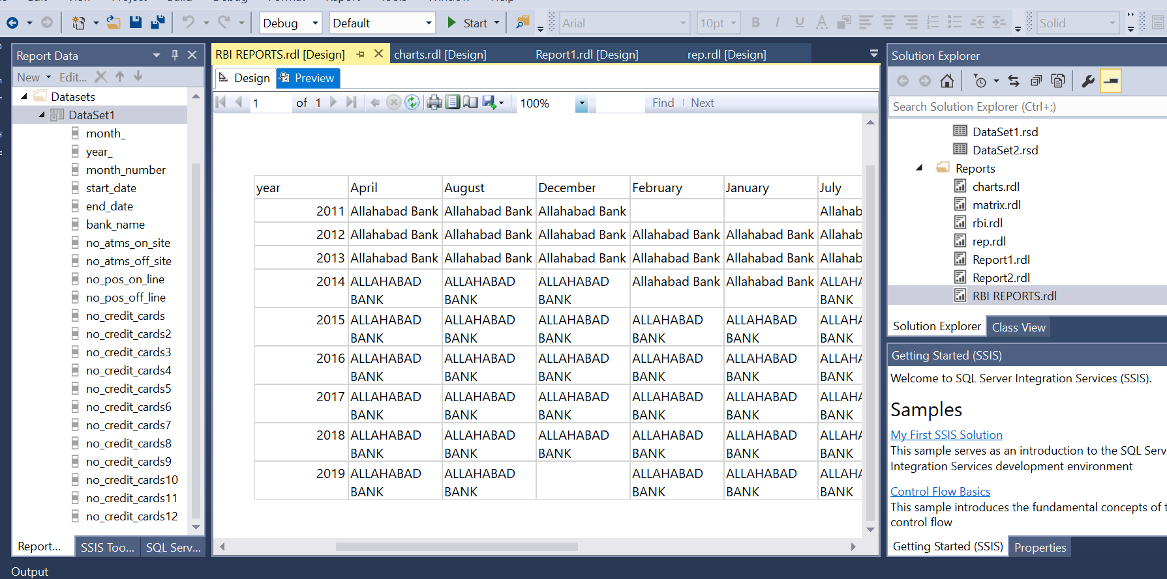

CREATING REPORTS IN SSRS

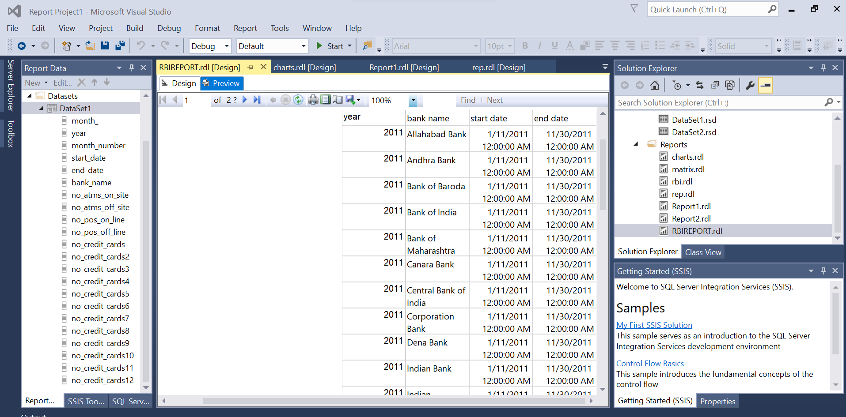

GROUPING

CREATING EXECUTION TIME AND USER ID WITH HEADER

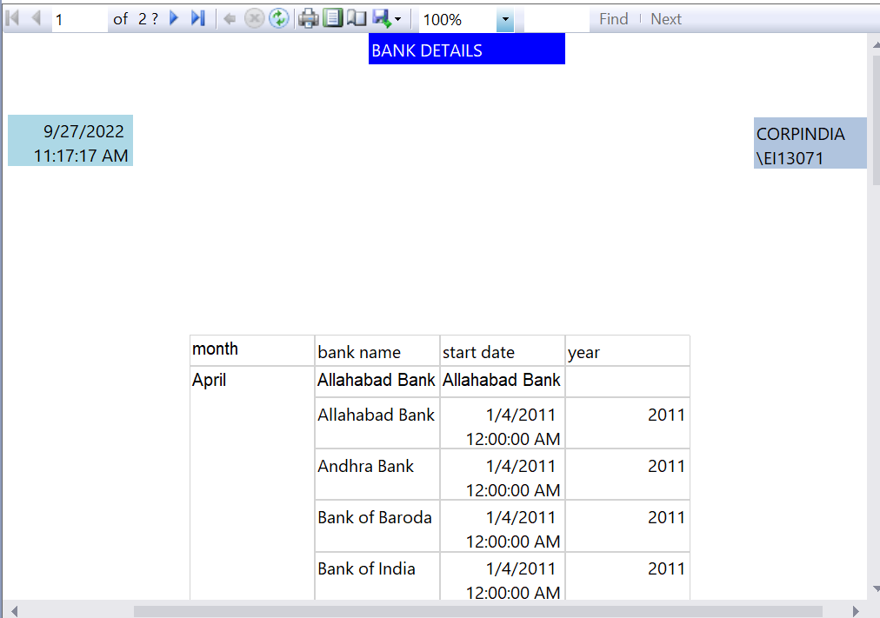

IICS

